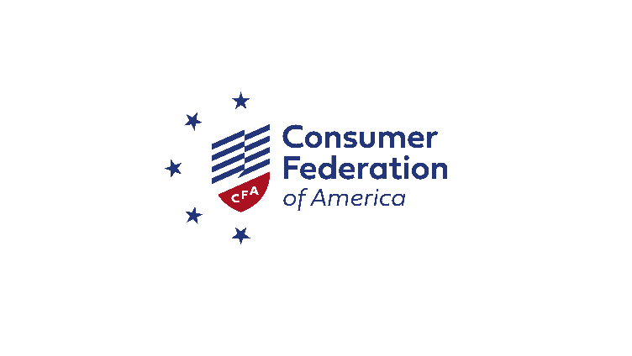

January 16, 2025

James P. Sheesley

Assistant Executive Secretary

Attention: Comments

Federal Deposit Insurance Corporation

550 17th St. NW

Washington, DC 20429

RE: Notice of Proposed Rulemaking, Recordkeeping for Custodial Accounts. RIN 3064-AG07

Dear Assistant Secretary Sheesley:

Thank you for the opportunity to comment on this proposed rule on recordkeeping for custodial accounts. The recent debacle at Synapse demonstrates the need for specific rulemaking on ledgering practices. The widespread failures by the institutions involved in bank-fintech partnerships have led to unprecedented harm to millions of depositors. At the root of the problem are emerging business practices that undermine confidence and trust in banks. The FDIC must address the shortcomings to ensure depositors can access the funds, check their balances, and be made whole in the event of bankruptcy by a non-bank or the failure of an insured depository.

The Consumer Federation of America (CFA) is an association of non-profit consumer organizations established in 1968 to advance consumer interests through research, advocacy, and education.

**Question: Should there be a minimum threshold for applying the requirements of the rule?**

*Rules that create standards for depositor protections should not be tailored to soften duties for smaller banks or for banks that are not significantly engaged in offering accounts that have custodial arrangements.*

We support the FDIC's decision not to apply a threshold that would exempt some banks from the rule based on their size.

The issues with custodial accounts are associated with how the deposits are insured, and the protections needed by depositors do not vary if they place their funds in a smaller bank. The perils from these accounts resulted from systematic compliance failures by bank partners and a lack of accountability by the banks. The solution proposed by some is to tailor corrective actions with thresholds that would exempt some institutions based on size. This approach makes no sense; in fact, it would significantly blunt the impact of a regulatory fix. For the most part, almost every bank engaged in a fintech partnership program has fewer than $10 billion in assets. Many manage their balance sheets to stay well below the threshold. The bank-fintech partnership is a small bank issue. Unless rules providing exemptions on debit interchange rate caps for smaller banks are altered, it will remain a field where smaller banks have a structural financial advantage.

Additionally, many custodial arrangements work through a group of program banks. The existence of a threshold could mean that some partner banks were covered by rules, but others were not, even if they were associated with the same fintech program and effectively served the same depositors.

**Question: Should the rule's recordkeeping requirements instead apply to all custodial deposit accounts, not only to those with "transactional features" as described in the proposed rule? Why and what would be the benefits or challenges of applying the requirements to all custodial deposit accounts?**

*Custodial accounts with transactional features should encompass sweep accounts whose balances can be altered by transactions on a linked account.*

The rule should narrow how it defines accounts at deposit placement networks. Some accounts that use this model are still closely tied to transaction accounts.

Some fintechs offer accounts that operate a nightly sweep of surplus deposits in a transaction-capable deposit account to a custodial sweep account. Sometimes, the sweep moves funds from a fully insured deposit account to a set of program partner custodial accounts. These are a hybrid form of sweep and transaction accounts.

For example, funds deposited in a Wealthfront Cash Account are held by Green Dot Bank. The account is fully transactional: it has a debit card, can receive deposits by direct deposit, ACH, or remote check deposit, provides ATM network access, and can send ACH transfers. Indeed, this account deserves the protections contemplated by the FDIC's proposal. However, the sweep account should also qualify, given that the debits and credits of an associated transaction account impact its balances. If the custodial balances were lost because of a bank failure, it would be essential for those funds to be traceable.

**Question: Are there other categories of custodial deposit accounts with transactional features that should be revised or narrowed? If so, why and how should the exemption(s) be revised?**

The FDIC should not provide an exemption for accounts holding security deposits. Existing fintechs have introduced accounts for "tech forward landlords"[1] and single-property real estate investors[2] designed to keep security deposits. Funds in these accounts are held in pass-through insured accounts. A sizeable available market exists that could be drawn to these accounts. There are millions of independent rental property owners. Many use an individual debit card for each property. Many seek a high-yield account to hold security deposits. If exempted, a failure by a key stakeholder could endanger the short-term availability of security deposits of many rental households.

**Question: Are custodial deposit account arrangements becoming more complex in the industry to the point where it would not be clear who is an account holder in the case of an IDI's failure? If so, how can the proposal better add clarity to support the FDIC's policy objectives?**

Yes. Emerging practices have undermined the ability of consumers to know how their funds are insured or even the name of the bank they are being held. Some consumers may know to see what bank has issued their fintech-branded debit card, but far fewer are likely to understand the implications of a bank partner consortium. Moreover, it is unlikely they could receive an answer from a customer service representative.

*Disclosures should provide greater clarity on how funds are insured.* Many fintech accounts fail to state clearly if funds are held in the name of the consumer or if they are in an account funded by pass-through insurance. Sometimes, fintechs say the funds are held in an insured account or at a bank with FDIC insurance. This language is entirely too opaque. There should be standardized language that distinguishes between the arrangements. The FDIC must hold banks accountable for conveying the information in a manner that has been proven to be understandable to depositors.

*Consumers should know which bank holds the funds in an FBO arrangement.* Banks pool funds and then move them in bundles to multiple banks. The consumer thinks their funds are at the bank whose name is identified on the issued debit card, but in fact, they may be at one or several other institutions.

The lack of clarity serves the interests of banks at the expense of depositors. Banks move these funds to generate arbitrage on interest rates. By moving the funds to chase yield, they earn profits on the margins. There is no corresponding benefit to depositors, but there is less clarity and potentially more risk.

The FDIC could address this problem by requiring issuing banks to disclose the name of the custodial bank to the depositor.

*The FDIC should require banks to state if funds are in a pass-through account.* The current system, where these funds are characterized as insured in a way that is indistinguishable to consumers from traditionally insured demand deposits, is not acceptable. One option would be to prohibit any funds in pass-through accounts from being described as insured. But even if they are characterized as receiving pass-through insurance, the difference must be made clear to depositors. Today, tens of millions of depositors have funds held in pass-through insurance accounts, and it is unlikely that even a small share of them understand the practice.

While the FDIC has published articles about third-party apps stating clearly that FDIC insurance does not apply if a non-bank (fintech) company fails, it should act to place this information before more consumers and in ways that are simpler to understand. A brief survey of popular fintech accounts finds that some now say "deposit insurance only covers the failure of an FDIC-insured bank" (Current)[3] or "deposit insurance covers the failure of an insured bank. Certain conditions must be satisfied for pass-through deposit insurance to apply" (Chime).[4] The information is in light 6-point font at the bottom of the browser page and virtually invisible on apps. An improvement would state the risks more clearly, in larger type size, in a much more visible location.

*To ensure banks have direct, continuous, and unrestricted access to the records of the beneficial owners, they should have arrangements in place to guarantee that contractors involved in any aspect of ledgering will be paid in the event of a business failure by the fintech or BaaS provider.*

When the financial stability of Synapse worsened, its management fell behind on payments to its third-party contractors. One of the firms that went unpaid had the contract to manage cloud storage of databases used for ledgering. The company chose to continue to provide access to records voluntarily – and without pay – but the security of customer records must be guaranteed by more substantial support. Banks should be required to see that funds are placed in escrow to address this situation.

Part 3, Contract Negotiation, Section g. Ownership and License of the 2023 Third-Party Guidance on Risk Management stresses the importance of escrow agreements to provide access to source code in the event of certain conditions, including a third party's insolvency.[5] The FDIC should clarify that this expectation also applies to third parties involved in the ledgering of depositor records.

**Conclusion**

Thank you for the opportunity to provide comments on this urgent issue. As the FDIC notes in its proposal, new business practices have led to new types of risks. The existence of a banking-as-a-service industry is still relatively novel, but it has grown dramatically. Many of these companies are led by individuals whose appetite for risk differs from the approach common in most traditional banks.

CFA commends the FDIC and other prudential regulators for their series of enforcement actions against banks that have taken dangerous risks when engaging in partnerships with fintechs. By making the compliance work of banks an essential strategic element to guarantee the ongoing business sustainability for fintech partners, prudential regulators have forced the system to prioritize compliance.

Nonetheless, the Synapse event underscores that more work must be done. Ledgering is a foundational activity of banking. Unfortunately, cost-cutting and risk-taking led to practices at some institutions that endangered consumers' deposits. CFA supports the FDIC's proposal to address these harmful practices and encourages it to conclude the rulemaking as swiftly as possible.

Please reach out to me if I can provide clarifications or answer additional questions.

Sincerely,

Adam Rust

Director of Financial Services

Consumer Federation of America

[arust@consumerfed.org](mailto:arust@consumerfed.org)

1. Baselane. "Security Deposit Account for Landlords." Accessed January 15, 2025. <https://www.baselane.com/security-deposit-account/>.
2. Vega/Canote, Jacob. "Landlord Banking | Stessa." Accessed January 15, 2025. <https://www.stessa.com/banking/>.
3. Current. "Current | Future of Banking." Accessed January 15, 2025. <https://current.com/>.
4. Chime. "Chime FAQs." Accessed January 15, 2025. <https://www.chime.com/apply-debit-f/>.
5. Federal Deposit Insurance Corporation, Office of the Comptroller of the Currency, and Board of Governors of the Federal Reserve System. "Interagency Guidance on Third-Party Relationships: Risk Management," June 6, 2023. <https://www.fdic.gov/news/financial-institution-letters/2023/fil23029.html>.