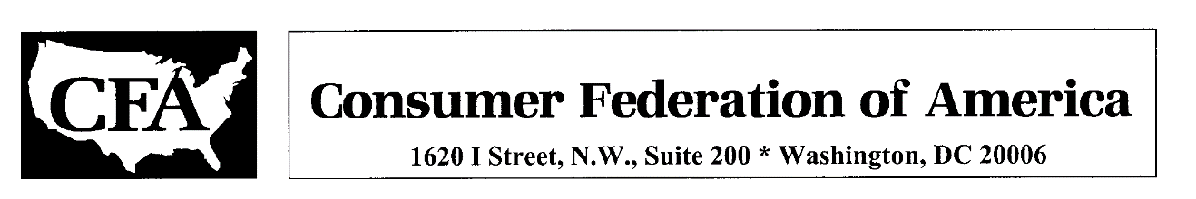
March 7, 2022
TO: Dear Speaker Jinkins, Minority House Leader Wilcox, and Members of the Washington State House of Representatives,
FROM: Susan Grant, Senior Fellow, Consumer Federation of America

RE: Oppose 2SHB 1850 and SB 5062

Consumer Federation of America (CFA), a nonprofit association of consumer organizations across the United States, urges you to oppose 2SHB 1850, the Washington Foundational Privacy Act, and SB 5062, the Washington Privacy Act. In the last version of 2SHB that we have seen, it would create a state privacy commission and enforcement mechanisms for the provisions of SB 5062, to which it refers. We strongly support state action to protect consumers’ privacy, but these bills would not accomplish that.
For the last four years, CFA and many other consumer, privacy, and civil liberty groups have opposed SB 5062 because it would not really change the commercial surveillance system that has developed in the absence of federal action on privacy. We have urged changes, and though Washington legislators have succeeded in getting some slight improvements made, much more is needed. Some have accused organizations that do not support SB 5062 of being unwilling to accept any bill that is not “perfect,” but perfection is not the aim. There is simply no point in enacting legislation that provides the illusion of privacy but does not, in fact, effectively protect Washingtonians’ personal data from unfair, unwanted and harmful collection and use.
Big tech companies are trying to help enact weak privacy laws in the states, such as Virginia’s Consumer Data Protection Act (CDPA), which was reportedly written by Amazon. Industry representatives contend that these laws can be strengthened after they have passed if needed, but what we saw in Virginia was that major data brokers attempted to weaken the CDPA this year, even before it has taken effect, by proposing that they should not be required to comply with one of the key provisions, consumers’ requests that their data be deleted. The companies behind the CDPA and that are working to enact SB 5062 are simply interested in protecting their ability to monetize consumers’ data, not in protecting their privacy.
In the last version of SB 5062 we have seen, there remains a number of problems. Among them, it:
- Does not require consumer consent for collection, use and sharing of data that is not necessary to complete the transactions or fulfill the requests they make;
- Does not give consumers the ability to prevent their data from being shared with companies’ affiliates, despite the fact that they may be unknown to the consumers and in very different lines of business than the parent companies;
- Allows personal information to be harvested from sources such as social media if consumers have failed to adequately restrict it;
- Would have no effect on the business models of companies such as Facebook and Google, who profit from tracking consumers’ activities on their websites and target them for ads on behalf of other companies;
- Creates a “right to cure” which hampers the ability of enforcement agencies to take action to stop companies who are violating the law and obtain recourse for consumers, and prevents consumers from taking legal action to enforce their rights.
- Allows companies to avoid responsibility for the actions of third parties with whom they share consumers’ data;
- Prohibits local jurisdictions from passing stronger privacy protections.
Because of its weaknesses, the bill does not have the support of the Washington Attorney General, who took the unusual step of sending a letter to state legislators advising that it would undermine consumers’ rights and erode existing protections.
We appreciate that many legislators are anxious to get something done on privacy, but we respectfully ask you to take more time to improve this important legislation, not only to ensure effective privacy protection for your constituents but to set an excellent example for other states to follow. We remain dedicated to helping you in any way we can. Please do not hesitate to contact me at sgrant@consumerfed.org.

