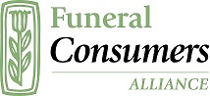
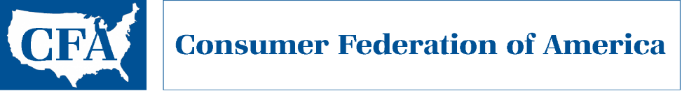

An Evaluation of
Consumer Information Provided by State Funeral Regulators

Joshua Slocum
Funeral Consumers Alliance

Stephen Brobeck
Consumer Federation of America

June 2021

Executive Summary

Consumers need good information about funeral homes that offer a variety of services which are relatively costly. State funeral service regulators are mandated to serve the public interest and are best equipped to provide consumers information about their rights, how to complain, and disciplinary actions. An evaluation of the consumer information on the websites of these state regulators found that only seven states provided excellent consumer information (earning an A grade) while 33 states (including DC) made available poor or no information (earning D or F grades). Funeral Consumers Alliance (FCA) and Consumer Federation of America (CFA) urge state funeral home regulators to improve the usefulness of consumer information made available on their websites.

Importance of State Regulators Providing Consumer Information

Consumers who plan funerals, many of them bereaved, face numerous choices about specific services whose total cost can range from under $2,000 to well over $20,000. Yet, surveys have shown that most consumers have a poor understanding of their rights and smart shopping strategies. For example, an FCA/CFA survey of 2,000 representative adult Americans earlier this year revealed that only 25 percent knew that funeral homes were required to provide price quotes over the phone and in an itemized price list.

Excluding Hawaii, all U.S. states and the District of Columbia have regulatory offices or boards that govern the commercial practice of funeral directing. Appendix A lists these regulatory agencies. The purpose of these regulatory bodies, according to the state laws that created them, is to protect the well-being of the public and consumers. States restrict the commercial practice of funeral directing to those who have demonstrated competency in the eyes of the state. In most states, licenses to practice are given only to those who have completed a two-year course of study in funeral directing and embalming, and who have passed an examination. The funeral regulators are also expected to investigate complaints against licensees and take disciplinary action where appropriate.
Accordingly, states have a mandate to serve the public, and some states recognize this mandate by providing good information to consumers. These states accept responsibility for helping consumers make wise choices. The states do this by offering the public information on their legal rights when making final arrangements, by suggesting smart shopping strategies, by explaining how to file complaints, and by identifying funeral homes which have been subject to disciplinary actions.

FCA and CFA evaluated the consumer information provided by state regulatory bodies on their websites. We examined the websites of the state funeral regulatory boards in all states (except Hawaii, which has no such board) and the District of Columbia. These websites ostensibly serve two audiences: the buyer of funeral services, and the professional provider. Consumer visitors are interested in learning about available options and the laws that protect the buyer’s interests. Professionals such as funeral directors seek information on requirements for licensure. We assessed each site’s usefulness to consumers, taking the point of view of the buyer, and imagining what he or she would find most useful.

Criteria for Assessment

We graded the consumer information provided by each state funeral regulatory board website on a scale from A (excellent) to F (poor). To achieve an A, a state funeral board website must include all of the following:
- A prominent link to consumer-focused information. This should be “top-level,” and intuitively labeled, not nested underneath a menu of choices unrelated to consumer information.
- An explanation of a consumer’s basic rights under the Federal Trade Commission’s “Funeral Rule.” This Rule, often mirrored by the state’s own requirements, gives consumers the right to choose services a la carte, receive price quotes by phone, and receive a printed itemized price list at a funeral home.
- An explanation of a consumer’s rights when buying a prepaid funeral. This should include an explanation of how much a consumer would be refunded if the contract is cancelled before death, or if the prepaid money is assigned to a new funeral home at the customer’s request.
- Other information about how consumers can optimize their purchase of funeral services, including links to the FTC website or publications on “Shopping for Funeral Services”.
- A prominent link to file a complaint.
- The ability to see whether a funeral home has been subject to disciplinary action by the regulatory body.

Using these criteria, two researchers independently evaluated each website then compared notes to arrive at a final grade. Websites earning a grade of A included all of this information prominently presented under a consumer heading. Websites receiving a B included less of this information but under a prominent consumer heading, or they included good consumer information but under a less intuitive topic heading such as “resources.” Websites earning a grade of C contained less consumer information and it was usually not prominently featured. Websites receiving a D contained little consumer information, and what was offered is not labeled prominently, or they offered no consumer-specific information at all. Websites with an F included no consumer information labeled as such, did not include a link to file a complaint, and did not provide information on past disciplinary actions against funeral homes.

Some states only partially meet one or more of the six criteria above. Wisconsin, for example, publishes a consumer brochure on prepaid funerals. This is helpful, but it is missing the most important information: What percentage of prepaid money will be refunded to consumers, per state law, if they transfer or cancel their prepayment before death. Merely advising consumers to ask that question without telling consumers what the law entitles them to – as Wisconsin does – is not sufficient.

State Grades

The majority of states did not meet our criteria for the minimum level of useful information for consumers. For this majority, the websites were designed primarily to serve funeral directors. It was easy to find information, such as the fee structure for initial and ongoing business licensing, but it was often not easy to find information relevant to the consumer (and in some cases, no such information was offered).

Seven states (14%) received an A grade, five states (10%) a B grade, five states (10%) a C grade, 26 states (52%) a D grade, and seven states (14%) an F grade. Hawaii was excluded from this evaluation since it has no state regulatory body overseeing funeral homes. The state grades are listed below.

Consumer Information Grades for State Funeral Bureaus
A |  | B |  | C
Arizona |  | Nevada |  | Florida
California |  | Oklahoma |  | Illinois
Kansas |  | Tennessee |  | Louisiana
Minnesota |  | Texas |  | Nebraska
New York |  | Washington |  | Wisconsin
Oregon
Virginia
D |  | F
Alabama |  | Alaska
Arkansas |  | Delaware
Colorado |  | Kentucky
Connecticut |  | Massachusetts
District of Columbia |  | North Dakota
Georgia |  | Pennsylvania
Idaho |  | Utah
Indiana
Iowa
Maine
Maryland
Michigan
Mississippi
Missouri
Montana
New Hampshire
New Jersey
New Mexico
North Carolina
Ohio
Rhode Island
South Carolina
South Dakota
Vermont
West Virginia
Wyoming

Model Website Elements

Websites that are most useful to consumers include the following elements:
- ease of use and clarity,
- an easy-to-use complaint form,
- complete information on disciplinary actions,
- advice on how to compare services and prices, and on consumer’s legal right to receive complete price disclosures, and
- relevant information on a consumer’s rights when purchasing pre-need.

The website of the Oregon Mortuary and Cemetery Board is a good example. The first screenshot shows the homepage. The consumer information is labeled plainly and placed prominently on the homepage. It includes links to consumer information on funeral planning, a complaint portal, and a link to past disciplinary actions.

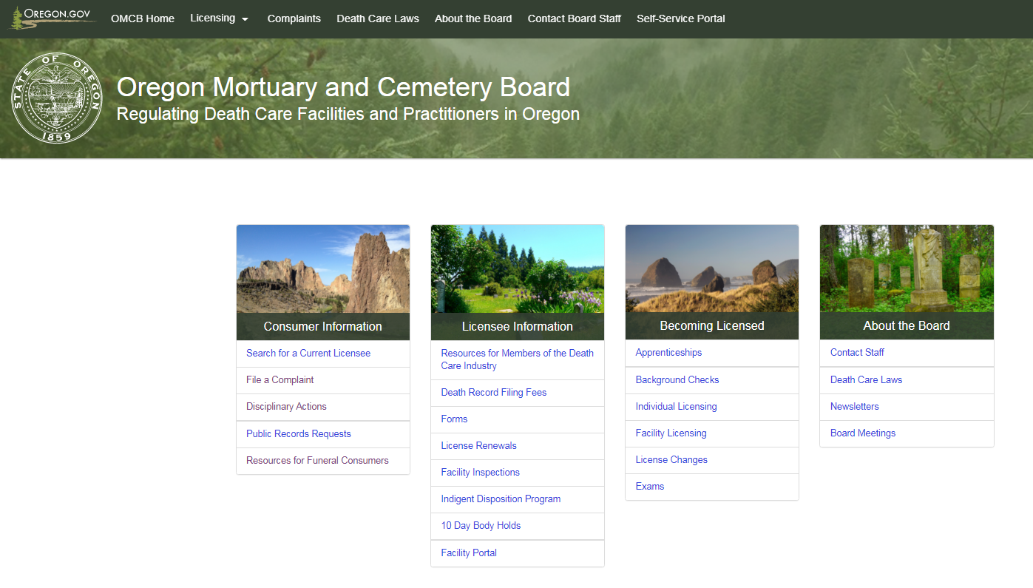

The second screenshot shows what a visitor finds when clicking the consumer information link. This “resources” section includes additional information of interest to consumers.

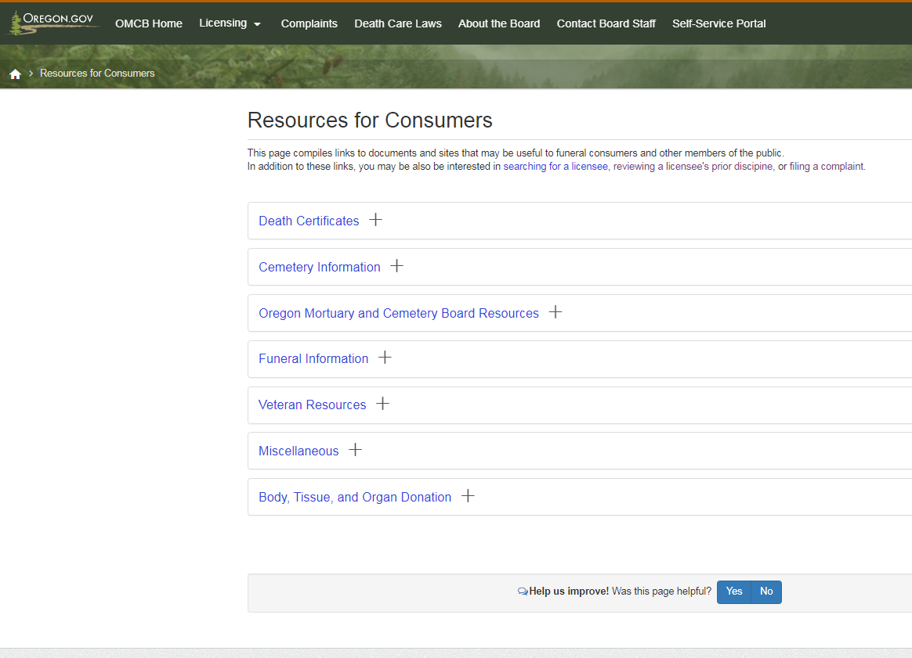

Arizona’s website also includes all the necessary elements presented in an easy-to-use manner. The first screenshot shows that the homepage includes two items useful to consumers: A static link labeled “consumers,” as well as a rotating display of images and links, one of which is labeled “consumer information.” Visitors following those links will find all of the pertinent consumer items discussed above (see second screenshot).

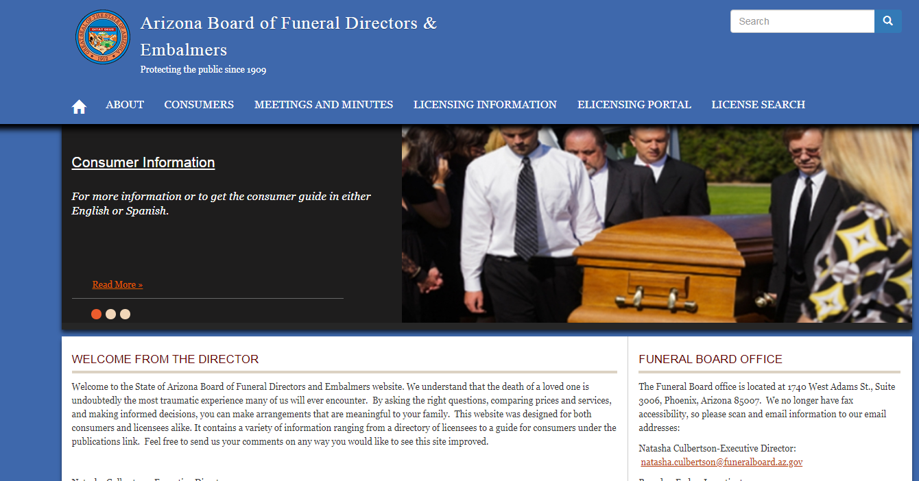
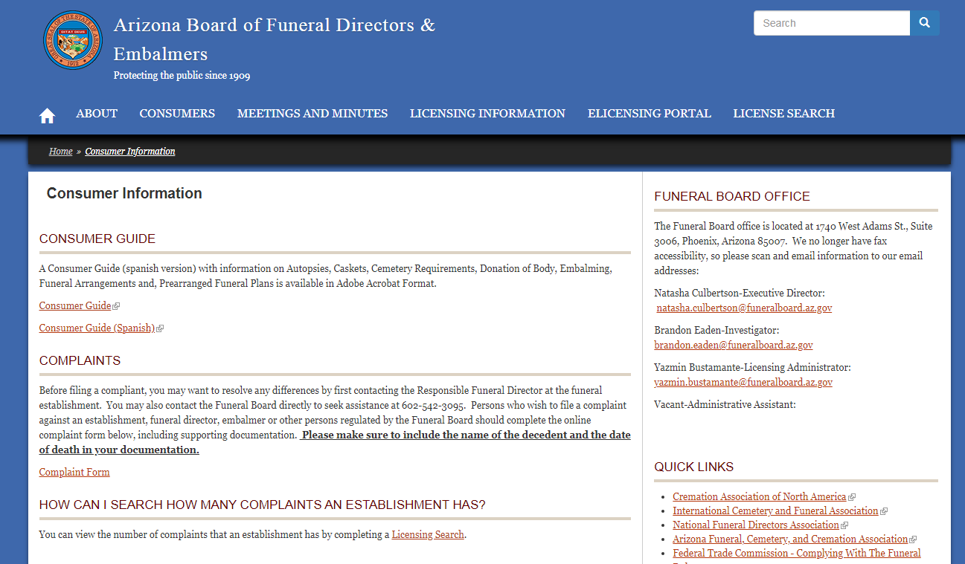

Conclusion

To state funeral home regulatory offices: The Funeral Consumers Alliance and Consumer Federation of America urge all state funeral regulatory agencies to ensure that consumers have attractive, easily accessible, and useful information about planning and purchasing funeral services. A number of states have made access to this information a priority. FCA and CFA urge all states to make a strong commitment to providing consumer information.

To consumers: FCA and CFA urge consumers in those states with at least a B grade, who are planning a funeral, to consult the website of their state funeral agency for information. We also recommend consulting two publications:
- Funeral Consumers Alliance, Consumer Federation of America, Planning a Funeral: 5 Key Tips
- Federal Trade Commission, Shopping for Funeral Services

APPENDIX A: STATE FUNERAL REGULATORY GROUPS

Alabama Board of Funeral Service
Alaska Division of Occupational Licensing
Arizona State Board of Funeral Directors and Embalmers
Arkansas State Board of Embalmers and Funeral Directors
California Cemetery and Funeral Bureau
Colorado Funeral Directors Association
Connecticut Department of Public Health
Delaware Board of Funeral Service
District of Columbia Board of Funeral Directors
Florida Department of Financial services
Georgia Board of Funeral Service
Hawaii Sanitation Branch
Idaho Board of Morticians
Illinois Professional services Section
Indiana State Board of Funeral and Cemetery Service
Iowa Board of Mortuary Science
Kansas State Board of Mortuary Arts
Kentucky State Board of Funeral Directors and Embalmers
Louisiana State Board of Embalmers and Funeral Directors
Maine Board of Funeral Service
Maryland State Board of Morticians
Massachusetts Board of Embalming and Funeral Service
Michigan Department of Licensing and Regulatory Affairs
Minnesota Department of Health Mortuary Science Section
Mississippi State Board of Funeral Service
Missouri State Board of Embalmers and Funeral Directors
Montana Board of Funeral Service
Nebraska Department of Health and Human Services Regulation and Licensure
Nevada State Funeral and Cemetery Services
New Hampshire Board of Registration of Funeral Directors and Embalmers
New Jersey State Board of Mortuary Science
New Mexico Board of Funeral Practice
New York Bureau of Funeral Directing, New York State Department of Health
North Carolina Board of Funeral Service
North Dakota State Board of Funeral Service
Ohio Board of Embalmers and Funeral Directors
Oklahoma State Board of Embalmers and Funeral Directors
Oregon State Mortuary and Cemetery Board
Pennsylvania State Board of Funeral Directors
Rhode Island Division of Professional Regulation
South Carolina State Board of Funeral Service
South Dakota Board of Funeral Service
Tennessee State Board of Funeral Directors and Embalmers and Burial Services
Texas Funeral Service Commission
Utah Division of Occupational and Professional Licensing
Vermont Board of Funeral Service
Virginia Board of Funeral Directors and Embalmers
Washington Board of Funeral Directors and Embalmers
West Virginia Board of Funeral Service Examiners
Wisconsin Department of Safety and Professional Services
Wyoming State Board of Funeral Service Practitioners

